Logan Hammond

9 February 2020

SDEV 300, Fair

Lab 4 Results Document

# MatrixOps

|  |  |  |  |  |
| --- | --- | --- | --- | --- |
| Test Case | Input | Expected Output | Actual Output | Pass? |
| 1a | Valid input* | Valid output | Valid output | Yes |
| 1b | Input containing non-integers, invalid chars, or whitespace. | Require valid user input. | Require valid user input. | Yes |
| 1c | Input containing less or more than 9 integers | Require valid user input. | Require valid user input. | Yes |

* Valid input consists of exactly 9 positive integers separated by commas without whitespace.

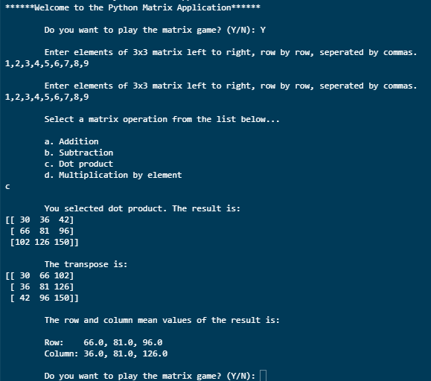

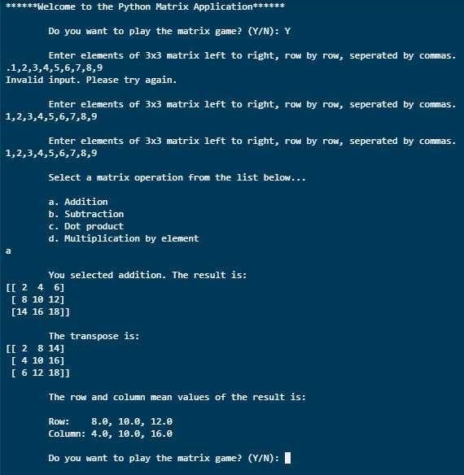

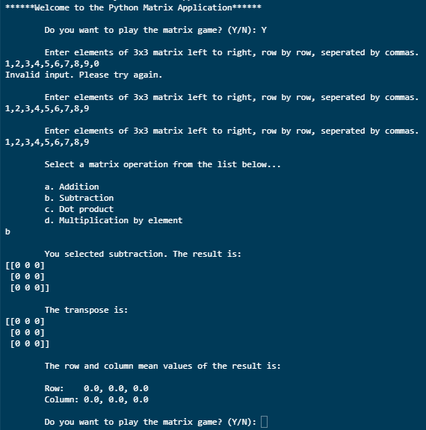

# RecordOps

